3.4.1 Water Suppliers and Managers 2
3.4.1.1 Types of Suppliers 2
3.4.1.2 Major Urban Water Suppliers 2
Casitas Municipal Water District 4
Ventura Water 4
Golden State Water Company 4
Ventura River Water District 5
Meiners Oaks Water District 6
3.4.1.3 Mutual Water Companies 7
3.4.1.4 Private Wells and Diversions 8
3.4.1.5 Water Management Organizations 9
Ojai Basin Groundwater Management Agency 9
Ventura County Watershed Protection District 9
Ojai Water Conservation District 10
3.4.1.6 Key Data and Information Sources/Further Reading 10

3.4.1 Water Suppliers and Managers
3.4.1.1 Types of Suppliers
The watershed has several different types of water suppliers; the differences are mostly in the type of ownership, methods of payment or reimbursement for water, and the governing bodies. Different regulations and procedures may apply to different types of water suppliers. The following descriptions are taken from the Ventura County Watershed Protection District’s Inventory of Public & Private Water Purveyors in Ventura County (VCWPD 2006).
Cities—Any charter or general law city is a public agency that can provide water service as a city function.
Special Districts—Special districts are public agencies formed pursuant to general or special laws, generally for the local performance of government or proprietary functions within limited boundaries.
Public or Special-Use Public Water Suppliers—These are public water suppliers other than cities or special districts. In the Ventura River watershed these are parks, campgrounds, and County facilities.
PUC-Regulated Private Water Companies—In a limited number of cases, the California Public Utilities Commission (PUC) licenses and regulates water companies. These private companies have rates and service areas established by the State PUC. They are not owned by any public agencies or by the affected customers, but usually by shareholders who purchase stock or ownership rights via bond issues, etc.
Mutual Water Districts or Companies—Somewhat like PUC-regulated water companies but with much fewer restrictions, mutual water districts or companies are owned in common by the various shareholders or customers served by the company.
Privately Owned Water Companies—A popular and easily established form of water service is the private company. These include limited partnerships, private landowners, mobile home parks, and irrigation-only companies. Customers may or may not own shares in the company, depending on the size of the purveyor.
In addition, many individuals and businesses in the watershed, especially farmers, have private wells and therefore serve as their own “supplier.”
3.4.1.2 Major Urban Water Suppliers
There are five major urban water suppliers in the Ventura River watershed: Casitas Municipal Water District, Ventura Water, Golden State Water Company, Ventura River Water District, and Meiners Oaks Water District. These major urban water suppliers are described briefly below; more information on the suppliers is provided in “3.4.2 Water Supplies” (including a map of water supply key infrastructure) and “3.4.3 Water Demands.”
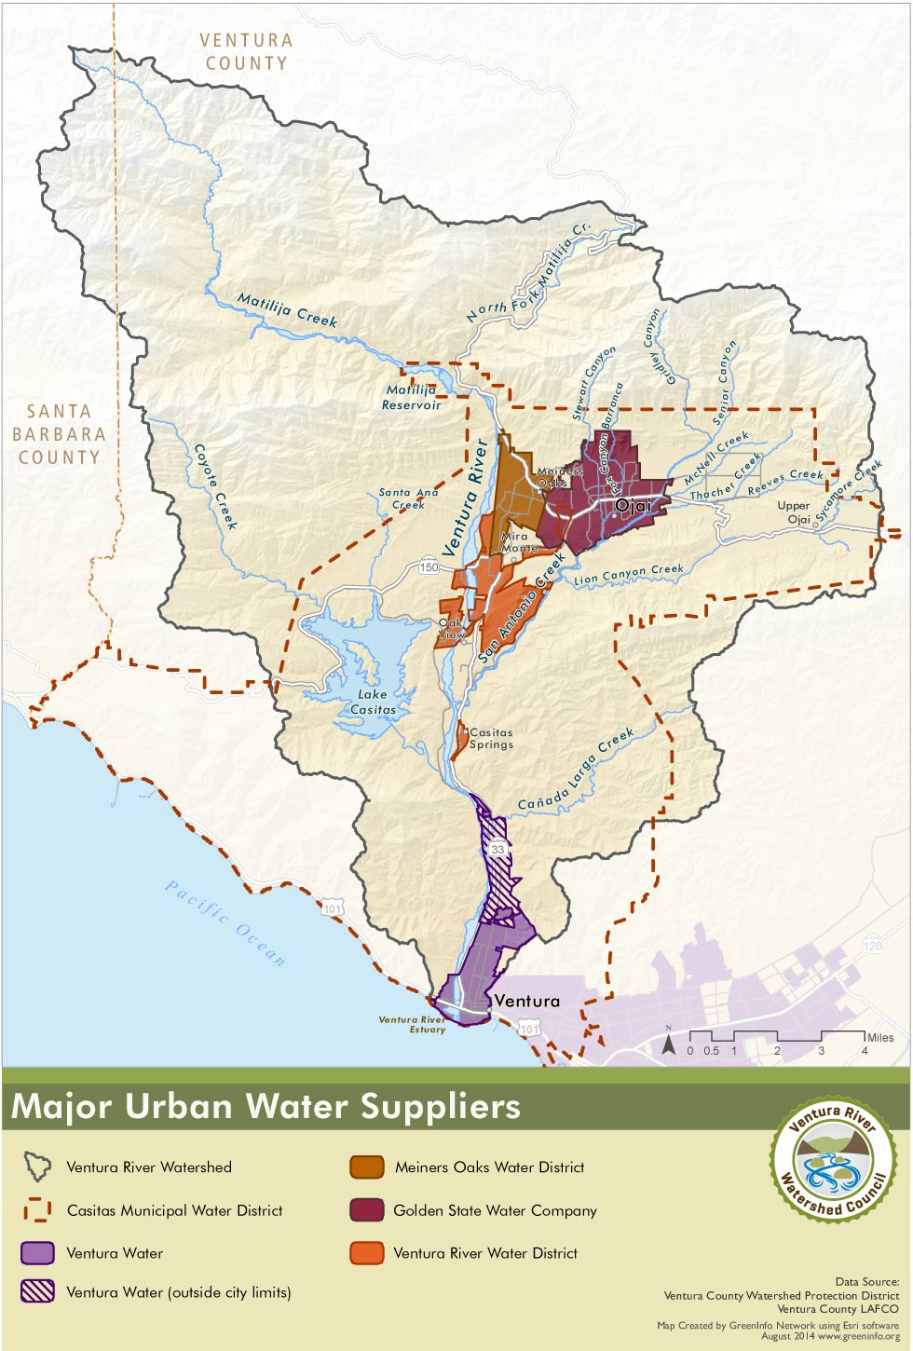
Figure 3.4.1.2.1 Major Urban Water Suppliers Map
Casitas Municipal Water District
Casitas Municipal Water District (CMWD) is the primary water supplier in the watershed, providing water to both water resale agencies and retail customers. The City of Ventura is Casitas’ largest customer, and Lake Casitas water serves as one of the main sources of water for the City of Ventura. One of CMWD’s important functions is to serve as the “backup” water supply for a number of their customers, including nine water suppliers, as well as farmers, when groundwater supplies become depleted.
CMWD’s service area encompasses 137 square miles and includes the City of Ojai, Upper Ojai, the Ventura River Valley area, the City of Ventura south to about Mills Road, and the coastal Rincon area to the Santa Barbara County line.
CMWD gets its water from Lake Casitas, which is fed by both the reservoir’s surrounding drainages and water diverted from the Ventura River. The district also operates one well in the Mira Monte area.
CMWD operates and maintains Lake Casitas and Casitas Dam, the Robles Diversion and Fish Passage Facility on the Ventura River, the Robles Canal, and the Marion Walker Pressure Filtration Plant. CMWD also maintains and operates one well in Mira Monte, which pulls from the Upper Ventura River Basin.
Ventura Water
Ventura Water is the name of the City of Ventura’s department that supplies water and treats wastewater. Ventura Water’s service area is within their city limits (22 sq. mi.), which comprises several watersheds, including the lower part of the Ventura River watershed east of the Ventura River (primarily the City’s Westside). They also supply water to an area in the watershed of about 944 acres that is outside their city limits but within their sphere of influence.
Lake Casitas is one of Ventura Water’s primary supply sources. The water received from CMWD may only be used in the part of the City within CMWD’s service area (4,112 acres), which extends to about Mills Road. There is an exception to this in Casitas’s 1995 contract with the City allowing them to “rent” water from Casitas (and return it later) for use outside of Casitas’s service area (CMWD 1995); this contract is being reconsidered for relevance to current water supplies and demands.
Water from wells and diversions in the Foster Park area is another primary water source of Ventura Water. Water from this source may be used anywhere within Ventura Water’s service area. Ventura Water also depends upon groundwater from sources in the Santa Clara River watershed.
In the Ventura River watershed, Ventura Water operates four groundwater wells at Foster Park (one of which is not currently operational because of damages sustained in the 2005 flood). These wells pull water from the downstream end of the Upper Ventura River Basin. Ventura Water also has both a surface and subsurface intake on the Ventura River at Foster Park (though the surface diversion has not been operational since 2000).
Ventura Water operates the Avenue Water Treatment Plant, which treats water from the Foster Park wells and diversions.
Golden State Water Company
Of the five major urban water suppliers in the watershed, Golden State Water Company is the only PUC-regulated private water company. Golden State also owns and operates several other water systems in California. In the Ventura River watershed their service area includes the City of Ojai proper, part of the unincorporated County east of the City of Ventura and part of the Meiners Oaks community to the west of Ojai. Golden State’s main source of water is groundwater, which they supplement with water from CMWD.
Because of high water cost rates relative to other rates in the area, as well as complaints related to service, customers of Golden State in the City of Ojai initiated an effort in 2010 to have CMWD acquire the Ojai service area of Golden State and become the area’s service provider. In 2013, voters approved a bond to fund the cost of acquiring the water system and making needed improvements. As of this writing, this issue is being litigated.
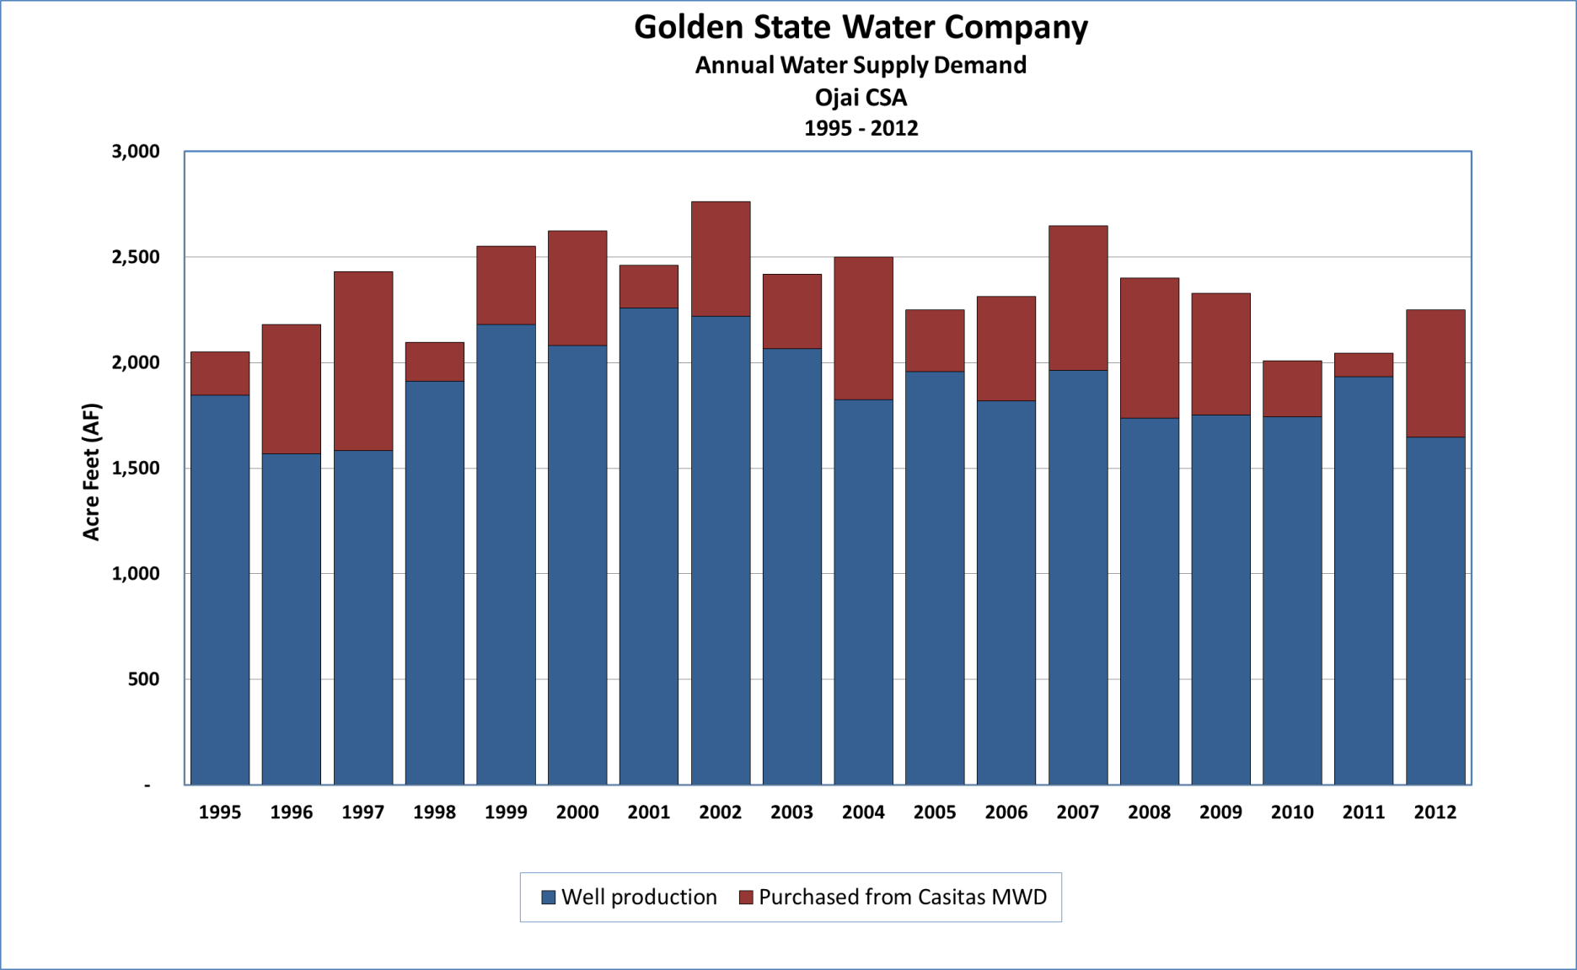
Figure 3.4.1.2.2 Golden State Water Company Annual Water Use by Source
Source: GSWC 2013
Golden State operates five wells in the Ojai Valley Groundwater Basin. They have two connections to CMWD (City of Ojai 2012).
Ventura River Water District
Ventura River Water District (VRWD) is a small water district that supplies water to the area stretching from the southwestern edge of the City of Ojai down to the northern half of Oak View, and in the eastern half of Casitas Springs. Groundwater is VRWD’s primary water supply source. CMWD water is also used, both as a backup source and as a regular source for customers in some locations.
When full, our aquifer holds about a two year supply of water. If we do not receive sufficient rain after that we must rely upon water from Lake Casitas.
⎯Ventura River Water District website (VRWD 2014)
VRWD operates four wells in the Upper Ventura River Groundwater Basin, and has five water system connections to receive water from Lake Casitas.
Meiners Oaks Water District
Meiners Oaks Water District (MOWD) is a small water district that supplies water to the community of Meiners Oaks on the east side of the Ventura River. Groundwater is MOWD’s primary water supply source. Water from CMWD is infrequently used as backup, such as during extended drought periods.
MOWD operates five wells in the Upper Ventura River Groundwater Basin.
Table 3.4.1.2.1 Major Urban Water Suppliers, Overview
Major Urban  Water Supplier | Purveyor Type | Year Formed | Area Served | Est. Pop. Served | # of Connections
Casitas Municipal Water District (CMWD) | Special District | 1952 | Wholesale boundaries include the City of Ojai, Upper Ojai, Ventura River Valley area, the City of Ventura to Mills Road, and the coastal Rincon area to the Santa Barbara County line. 137 sq. mi. | 9,379 R  68,557 R+W | 3,200
Ventura Water | City | 1923 | City of Ventura¹  In watershed: 1,798 acres within City + 944 acres within City’s sphere of influence  In CMWD service area: 4,112 acres  Overall: 22 sq. mi. of City + 944 acres within City’s sphere of influence | 106,433 (entire city)  31,604²  (Casitas’s service area within city) | About 32,000 service connections; approximately 30% of those accounts (~9,600) are located within the CMWD service area.
Golden State Water Company | Investor-Owned Utility | 1928 | City of Ojai proper and some fringe County areas outside the City. 3,300 acres. | 8,202 | 2,899
Ventura River Water District | Special District | 1957 | Part of Casitas Springs, Burnham Road area west of the Ventura River, and north half of Oak View up to Meiners Oaks and to the City of Ojai at the Vons shopping center. 2,220 acres. | 5,988 | 2,150
Meiners Oaks Water District | Special District | 1948 | Meiners Oaks community on the east side of the Ventura River. 1,300 acres. | 4,000 | 1,260
R = Retail, W=Wholesale. Because they are a wholesale provider, Casitas’ service area encompasses that of the other districts; it also extends beyond the watershed’s boundaries.
1 Ventura Water may use Casitas water within Casitas’s service area, which extends to about Mills Road, but this restriction does not apply to use of Ventura River water from the City’s Foster Park facilities.
2 Estimated with a GIS tool using Census Block Groups.
Sources: Kennedy/Jenks 2011, Rapp 2013, Hollebrands 2013, CDWR 2013, RBF 2013, USCB 2014

Table 3.4.1.2.2 Water Sources of Major Urban Water Suppliers
Major Urban  Water Supplier | Water Sources
Casitas Municipal Water District | Lake Casitas, which is fed by both its surrounding drainages and water diverted from the Ventura River. The district also operates 1 well in the Mira Monte area, in the Upper Ventura River Basin.
Ventura Water | Sources from the Ventura River watershed include CMWD and Foster Park wells and diversions. Ventura Water operates 4 groundwater wells at Foster Park (one of which is not currently operational because of damages sustained in the 2005 flood), and both a surface and subsurface intake on the Ventura River at Foster Park (though the surface diversion has not been operational since 2000s). Groundwater is extracted from the Upper Ventura River Groundwater Basin. Ventura Water also has rights to reclaim water from the Ojai Valley Sanitary District treatment plant. Reclamation of this water source is currently under study.
Golden State Water Company | 5 wells in the Ojai Valley Groundwater Basin, plus water from CMWD.
Ventura River Water District | 4 wells in the Upper Ventura River Groundwater Basin, plus CMWD water as backup.
Meiners Oaks Water District | 5 wells in the Upper Ventura River Groundwater Basin, plus CMWD water as backup.
3.4.1.3 Mutual Water Companies
There are 11 water mutual companies in the watershed as summarized in Table 3.4.1.3.1. They range from small companies serving 10 to 12 customers, to companies serving hundreds of customers. The majority of these mutual water companies were formed back in the 1930s and 40s. Antiquated infrastructure and equipment present management challenges for some of these older water companies.
Table 3.4.1.3.1 Small Water Suppliers, Overview
Water Supplier | Year Formed | Service Area | Est. Pop. Served | # of Connections | Water Sources
Casitas Mutual Water Company | 1932 | Serves residents in Casitas Springs, west of Highway 33. | 250 | 81 | Groundwater (Upper Ventura River Basin)
Gridley Road Water Group | 1930 | Serves primarily agriculture in the area of the Gridley Road and Grand Avenue intersection in the East End of the Ojai Valley. | 44 | 20 | Groundwater (Ojai Valley Basin), Golden State
Hermitage Mutual Water Company* | 1975 | Serves primarily agriculture and several large residential estates located in the foothills between Gridley and Senior canyons north of the Ojai Valley. | 35 | 22 | Gridley Canyon Creek, Groundwater (Ojai Valley Basin), CMWD
North Fork Springs Mutual Water Company | 1948 | Serves residential users located up Highway 33, north of the City of Ojai, E. of the Matilija Reservoir, in the Los Padres National Forest. | 10 | 11 | Groundwater (Upper Ventura River Basin)
Old Creek Road Mutual Water Company | 1975 | Serves residential users along East Old Creek Road | 12 | 5 | CMWD
Rancho Matilija Mutual Water Company | Pre- 1960 | Serves agricultural parcels in the Rancho Matilija subdivision, north of Baldwin Road and west of Meiners Oaks | 0 | 8 | Groundwater (Upper Ventura River Basin), Ventura River surface water
Rancho del Cielo Mutual Water Company | 1977 | Serves residential and agricultural users along Creek Road (along San Antonio Creek) | 18 | 7 | CMWD
Senior Canyon Mutual Water Company | 1929 | Serves the northeast end of the Ojai Valley (north of Reeves Creek, east of Carne Road). Serves a mix of residential, large residential, and agricultural users. | 800 | 247 domestic metered; 48 irrigation | Groundwater (Ojai Valley Basin), 2 spring/creek diversions, CMWD
Siete Robles Mutual Water Company | 1940 | Serves a housing tract located east of the City of Ojai. | 245 | 98 | Groundwater (Ojai Valley Basin), CMWD (minimal)
Sisar Mutual Water Company | 1949 | Serves the Summit area of the Upper Ojai Valley (partially within CMWD’s service area boundary). | 325 | 103 | Groundwater (Upper Ojai Basin), CMWD
Tico Mutual Water Company | 1949 | Serves a small residential area in Mira Monte, west of Highway 33. | 77 | 38 | Groundwater (Upper Ventura River Basin), CMWD
Sources: CMWD 2011, VCWPD 2006, WCVC 2006, Thompson 2014
There are also eight private water companies that deliver water in the watershed along with three public water suppliers that supply water to locations, such as County parks and facilities.
3.4.1.4 Private Wells and Diversions
Water is also supplied to many agricultural and domestic water users in the watershed by way of private wells and surface water diversions.
As of March 2014, 21 different entities were registered in the state’s eWRIMS (Electronic Water Rights Information Management System) database as having rights to withdraw surface water or water from subterranean streams in the watershed (SWRCB 2014b).
As of May 2014, there were 442 active wells in the watershed, 203 of which were drilled prior to local permit requirements.
Table 3.4.1.4.1 Active Wells in 2014
Groundwater Basin | Active Wells (approx.) | Drilled Before Permits*
Upper Ventura River Basin | 149 | 76
Lower Ventura River Basin | 15 | 3
Ojai Valley Basin | 182 | 98
Upper Ojai Basin | 96 | 26
Total | 442 | 203
Well records are approximate.
*Drilling permits became required in 1999.
Source: VCWPD 2014a
3.4.1.5 Water Management Organizations
Ojai Basin Groundwater Management Agency
Ojai Basin Groundwater Management Agency (OBGMA) is a special-act district that manages the water of the Ojai Valley Groundwater Basin. Formed by state legislation in 1991, OBGMA is one of only 13 such districts with groundwater management authority in the State of California (CDWR 2003). The watershed’s other three important water supply groundwater basins do not have similar management oversight. The agency was established in the fifth year of a drought, amidst concerns of local water agencies, water users, and well owners about potential groundwater basin overdraft (OBGMA 2010).
OBGMA’s mission is “To preserve the quantity and quality of groundwater in the Ojai Basin in order to protect and maintain the long-term water supply for the common benefit of the water users in the Basin.”
There are five seats on the OBGMA board, which are filled by representatives from the City of Ojai, Casitas Municipal Water District, Golden State Water Company, Ojai Water Conservation District, and mutual water companies (one director is elected to represent three mutual water companies).
The OBGMA oversees the management of the Ojai Basin, and is required by law to have a groundwater management plan to guide its operations. Elements of OBGMA’s Groundwater Management Plan are implemented in the form of policies, rules, regulations, and ordinances. Water drawn from the basin is used roughly equally between urban and agricultural users.
Ventura County Watershed Protection District
The Ventura County Watershed Protection District (VCWPD), originally named the Ventura County Flood Control District, was formed by state approval of the Ventura County Flood Control Act of 1944. This Act (as amended) includes five primary purposes of the VCWPD, including several related to water supplies:
- Provide for the control and conservation of flood and stormwaters
- Prevent waste or loss of water supply
- Import water into the district, retain and recycle storm and flood flows, and conserve all such water for beneficial uses.
Key programs and services that the district administers that support water supply management include:
- Lead role in monitoring and collection of precipitation, weather, and streamflows data
- Hydrologic modeling and forecasting
- Lead grant applicant/administrator in support of watershed partner projects, such as the San Antonio Creek Spreadings Grounds project
- Groundwater well permitting, groundwater data, and basin condition assessments
- Stormwater management programs that advance stormwater capture and infiltration.
VCWPD implements Ventura County Well Ordinance No. 4184, which includes issuing permits for modification, construction, and destruction of all types of wells; inspecting well sealing and perforation work; and conducting an annual well usage survey. VCWPD hydrographers regularly perform water level measurements and water quality sampling of approximately 200 wells located throughout Ventura County and produce an annual report summarizing those findings. VCWPD maintains records on all known wells within the County, including a database of wells that helps track well status (active/inactive/destroyed).
Ojai Water Conservation District
The Ojai Water Conservation District (OWCD) is a special district formed in 1949. The district’s focus is on reclaiming water in the San Antonio Creek area of the East End of the Ojai Valley for agricultural purposes. The district was formerly called the San Antonio Water Conservation District (VCWPD 2006). OWCD is authorized to monitor the use of groundwater, acquire water rights, store and spread water, and construct dams or other water facilities (VLAFCO 2004). The OWCD is within OBGMA’s service area, and is represented on OBGMA’s board.
3.4.1.6 Key Data and Information Sources/Further Reading
Below are some of key documents that address water suppliers in the watershed. See “4.3 References” for complete reference citations.
2010 Urban Water Management Plan (CMWD 2011)
2013 Comprehensive Water Resources Report, Ventura Water (RBF 2013)
2014 Comprehensive Water Resources Report, Ventura Water (RBF 2014)
Inventory of Public & Private Water Purveyors in Ventura County (VCWPD 2006)
Public Water System Statistics (CDWR 2013)
Ojai Basin Groundwater Management Agency, Annual Report (OBGMA 2010)
Water and Wastewater Municipal Service Review Report (VLAFCO 2004)

