**Goal: Clean Water**

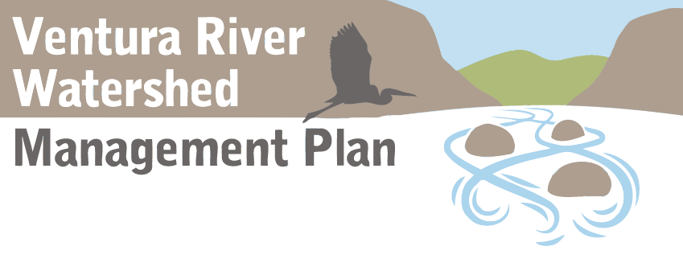

**Findings**

**Example only. Provided to demonstrate format, level of detail, length, etc.**

1. Water quality is fairly good compared to more developed watersheds in the region, has improved notably in recent decades, and is not threatened by significant new growth.
2. All of the watershed’s major water bodies are listed as “impaired” on the Clean Water Act Section 303(d) list of impairments, and maintaining and improving water quality is a key concern of many stakeholders.
3. Nutrient pollution, and the associated problems of eutrophication, algae growth, excessive aquatic plant growth and low dissolved oxygen, is considered the most significant surface water quality problem. Although regulations assign “responsible parties,” the research is inadequate to indicate the sources of nutrients of greatest concern.
4. Levels of nitrate exceeds standards in some wells in the watershed, and this water must be blended with other water before drinking. Constituents of concern to agricultural water users⎯total dissolved solids, chloride and boron⎯are also sometimes found in elevated concentrations. The Lower Ventura River Basin groundwater is minimally used because of high total dissolved solids and other quality issues.
5. Pollutants come from many diverse sources (non-point sources) more than from large single sources (point sources).
6. Because most of the watershed’s aquifers are unconfined, groundwater is more vulnerable to contamination from surface pollution than in confined aquifers.
7. Stormwater management measures in urban areas are not adequate to protect the Ventura River and its tributaries from pollution.
8. The wastewater treatment plant’s discharge is the primary “point source” of nutrients, as well as “constituents of emerging concern,” to the river. Although the discharge, which is put into the Ventura River, is of relatively high water quality, regulatory clean water targets call for significant and costly treatment plant upgrades. The plant’s discharge is a critical source of instream water that provides important aquatic habitat.
9. The low flow of water that is typical in the watershed’s river and creeks exacerbates most water quality problems, and is itself considered by regulators to be an impairment to the “beneficial use” of the river by the endangered southern California steelhead trout. The extent to which water diversions and groundwater pumping contribute to low flows needs further study.
10. The amount of money spent annually on required water quality monitoring and reporting is exceedingly high and out of proportion to the amount spent implementing projects and programs that could clean up the water and prevent pollution. The considerable water quality data collected is very valuable, yet inadequately analyzed and integrated, especially on a regional scale and over time.
11. Trash pollution has been a long-standing problem, but has seen significant improvements in recent years. Keeping ahead of this issue will require ongoing vigilance and resources.
12. San Antonio Creek has some of the most compromised surface water quality in the watershed, with some of the highest levels of nutrient pollution. The creek is on the Clean Water Act’s 303(d) list of impaired water bodies for bacteria, nitrogen, dissolved oxygen and total dissolved solids.
13. Indicator bacteria concentrations in urban runoff and in streamflow typically exceed standards right after rains. Canada Larga, the Ventura River estuary, San Antonio Creek and a stretch of the Ventura River are on the 303(d) list of impairments for bacteria or coliform.
14. Sewer mainlines are located in or immediately adjacent to the Ventura River and San Antonio Creek, and remain at risk of breaks and spills.