**Water Conservation Website Site Map**

Page 1 Main Page

Page 2 Free Onsite Water Use Surveys and Leak Detection

Page 3 Free Water Saving Equipment and Rebates

Page 4 Drought & Rainfall Information

Page 5 Water District Info and Map

Page 6 Water Stars Videos [already up]

Page 7 The Big Three

Classes & Events [not a separate page]**[Page 1] Ventura River Watershed**

**Water Conservation Webpage**

|  |  |  |
| --- | --- | --- |
|  | The Big 3 |  |
| **Free Onsite Water Use Surveys  & Leak Detection** | 1.  **Reduce Landscape & Farm Water Use** | **Classes & Events** |
| **Free Water Saving Equipment & Rebates** |
| h2ouse.jpg [Virtual Water Saver Home Tour](http://www.h2ouse.org/) | 2.  **Improve Wasteful Plumbing & Pipes** | **Water Stars Videos** |
| http://www.acwa.com/sites/default/files/imagecache/Spotlight_Logo/spotlight_icons/sow_0.jpg  [Association of California Water Agencies Website](http://www.saveourh2o.org/) |
| **Drought & Rainfall Information** | 3.  **Harvest & Reuse More Water** | **Twitter Timeline** |
| **Water District Info & Map** |

**[Page 2]**

**Free Onsite Water Use Surveys and Leak Detection**

[Index:

Residential and Commercial Water Use Surveys

Leak Detection

Agricultural Irrigation Evaluations

Hobby Farm Irrigation Evaluations]

**Residential and Commercial Water Use Surveys**

Larry Harris, water conservation coordinator for Casitas Municipal Water District, checks the flow rate of a showerhead.


Casitas Municipal Water District offers free, on-site water use surveys of single- and multi-family households as well as businesses within the district’s boundaries. The surveys can include both indoor and landscape water use.

The indoor surveys check for leaks, showerhead and faucet flow rates, toilet flush volumes, and the efficiency of all water-using appliances. The landscape survey includes reviewing the irrigation system, irrigation design, and watering schedules. The surveys also include meter reading to reveal possible system leaks.

Customers will be provided recommendations for improving water-use efficiency; and information on toilet, clothes washer and landscape rebates.

To schedule an appointment call 805/649-2251 x128. Appointments are available Monday thru Friday, between 8:30 am to 4:30 pm. [Casitas’ website.](http://www.casitaswater.org/lower.php?url=latest-news&article=free-water-surveys--now-available-to-residential-customers)

**Leak Detection**

Leak detection is an important part of water conservation. Constant leaks in plumbing are not uncommon. One of the most common sources of leaks in a house is from toilets, which can be relatively easy to correct.

Leaks waste not only water, but money. If your water bill has jumped but you don’t think you’ve increased water use, then you may want to find out if you have a leak. If you need help determining if a leak may exist, call Casitas Municipal Water District at 805/649-2251 x128 for assistance.

Chuck Kirman / The Star
A water meter at the home of Tia Andrews in Ojai.


Larry Harris, water conservation coordinator for the Casitas Municipal Water District, checks the water meter of homeowner Tia Andrews. The district offers a free water audit program to customers.


**Agricultural Irrigation Evaluations**

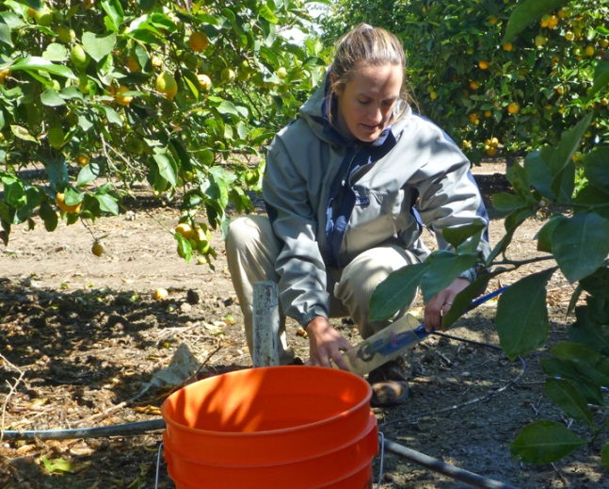

Free agricultural irrigation evaluations are available from the Ventura County Resource Conservation District’s (VCRCD) Mobile Irrigation Lab. This program provides on-site irrigation system analysis and technical assistance to improve water use efficiency. Growers learn how well their irrigation system is functioning and are provided with recommendations on how to improve their system’s performance to increase water use efficiency.

The VCRCD Mobile Irrigation Lab also includes a cost share program to help fund “best management practice” (BMP) implementation for irrigation systems of orchard, row crop, and nursery operations. As part of the Los Angeles Regional Water Quality Control Board’s “Ag Waiver” program to address water quality in Ventura County, growers must implement BMPs to help eliminate dry-weather runoff and improve water quality.

Funding through the cost share program can be used for such things as tensiometers, atmometers, drip and micro irrigation systems, and other types of equipment. As funding allows, growers can be reimbursed for up to 50% of eligible equipment costs, and an additional 50% of costs after demonstrating improvements in irrigation efficiency and reductions in water usage.

To sign up the VCRCD at 805/216-3641 or 805/764-5136. [VCRCD’s website.](http://www.vcrcd.org/irrigation-related-programs)

In addition, Casitas Municipal Water District offers growers in their district a $650 rebate for equipment that will help improve irrigation efficiency. Funds for this program are limited. For more information contact Casitas at 805/649-2251 x118 or rmerckling@casitaswater.com.

**Hobby Farm Irrigation Evaluations**

Free irrigation evaluations for “hobby farms,” those that are irrigating between 1 to 2 acres of crops, are also available from Casitas. (Farms larger in size qualify for Agricultural Irrigation Evaluations from the Resource Conservation District, discussed above.) The district will also provide up to $125 for water use efficiency equipment as part of these evaluations. Funds for this program are limited. For more information contact Casitas at 805/649-2251 x118 or [rmerckling@casitaswater.com](mailto:rmerckling@casitaswater.com).

**[Page 3]**

**Free Water Saving Equipment and Rebates**

[Index:

Free Water Saving Equipment

Water Saving Equipment Rebates

Agricultural & Hobby Orchard Irrigation Efficiency Equipment]

**Free Water Saving Equipment**

Casitas Municipal Water District offers free water conservation devices to all residents living in [the district’s wholesale service area](http://venturawatershed.org/wp-content/uploads/2013/05/MajorUrbanWaterSuppliers21.pdf), which includes most of the Ventura River watershed. Their service area includes the Ojai Valley, Upper Ojai, Meiners Oaks, Mira Monte, Casitas Springs, and Ventura’s Westside, as well as the Rincon area and the city of Ventura to about Mills Road. ([Service area map](http://venturawatershed.org/wp-content/uploads/2013/05/MajorUrbanWaterSuppliers21.pdf).)

The free devices available include low-flow (massage) showerhead, kitchen and bathroom faucet aerators (which slow the volume of water but keep the force), toilet flappers (which need to be replaced from time to time because they leak with age), and dye tablets (a quick way to test your toilet for leaks).

[add images from Casitas’ website]

To get your free water saving equipment, just go to the district’s office at 1055 Ventura Avenue in Oak View between 8:00 am and 4:30 pm. (Limit 2 per household.) You’ll be asked to sign a register that includes your address.

[**Casitas Municipal Water District Website**](http://www.casitaswater.org/lower.php?url=free-water-conservation-devices)

Casitas’s showerheads and aerators can also be picked up at the [Ojai Green Coalition’s Resource Center](http://ojaivalleygreencoalition.com/contact.shtml) at 206 N. Signal St. Suite S, which is open Wednesday thru Friday from 12:00 to 5:00 pm.

**Water Saving Equipment Rebates**

Get photos

Some great rebates on some great, water saving equipment are available to residents and businesses in the watershed. Rebates on high efficiency washing machines, toilets, and smart irrigation controllers are available to residents and businesses throughout [Casitas’ wholesale service area](http://venturawatershed.org/wp-content/uploads/2013/05/MajorUrbanWaterSuppliers21.pdf). Casitas also offers, on a limited basis, rebates for irrigation efficiency equipment to farmers and those with “hobby orchards.”

Rebates on rain barrels are available to residents of the city of Ventura, and customers of Golden State Water Company (primarily city of Ojai) may receive rebates on efficient sprinkler nozzles.

[High efficiency residential and commercial washing machine and toilet rebates](http://www.cuwcc.org/Resources/ConservationatHomeandWork/SmartRebatesProgram.aspx) are administered through the California Urban Water Conservation Council. Their website includes a link to the required application and a phone number to call for questions.

[Smart Irrigation Controllers rebates](http://www.casitaswater.org/lower.php?url=smart-irrigation-controller-rebates) are administered through Casitas. See their website for terms and conditions.

[Rain Barrels (City of Ventura residents only)](http://www.cityofventura.net/files/file/RainBarrelVoucher%20for%20website.pdf)

[Efficient Sprinkler Nozzle (Golden State Water Company customers only)](http://www.gswater.com/ojai/download/conservation_rebates/Ojai%20CSA.pdf)

**Agricultural & Hobby Orchard Irrigation Efficiency Equipment**

Growers located within Casitas Municipal Water District’s [wholesale service area](http://venturawatershed.org/wp-content/uploads/2013/05/MajorUrbanWaterSuppliers21.pdf) are eligible to receive a $650 rebate for equipment that will help improve irrigation efficiency. This offer is paired with the free irrigation evaluations available from the [Ventura County Resource Conservation District](http://www.vcrcd.org/irrigation-related-programs). Casitas also offers rebates of $125 for irrigation efficiency equipment to those with “hobby farms” in their district that participate in a free irrigation evaluation provided by Casitas. Funds for both of these programs are limited. For more information contact Casitas at 805/649-2251 x118 or rmerckling@casitaswater.com.

**[Page 4]**

**Drought & Rainfall Information**

[Index:

Current Conditions

Drought

Rainfall]

**Current Conditions**

[Lake Casitas Water Level](http://www.casitaswater.org/lower.php?url=lake-level)

[Current Rainfall](http://www.vcwatershed.net/fws/gmap.html)

Automated Daily Rainfall [Report](http://www.vcwatershed.net/fws/AutoMedia.htm)

[Current Streamflow](http://www.vcwatershed.net/fws/VCAHPS/)

Ojai Valley Basin Well Water Levels (Static/[Nonpumping](http://www.obgma.com/static_water_levels.html))

[Historic Rainfall & Streamflow Data](http://www.vcwatershed.net/hydrodata/)

**Drought**

In January, 2014, the Governor declared a [Drought State of Emergency for California](http://gov.ca.gov/news.php?id=18368" \t "_blank), and in April called on citizens to [redouble their efforts](http://gov.ca.gov/news.php?id=18496" \t "_blank) to conserve water. The Governor has urged an immediate 20% reduction in water use.

**Lake Casitas Water Level and Drought**

Water users in the Ventura River watershed have been asked by local water districts to voluntarily reduce their water use. The [water level of Lake Casitas](http://www.casitaswater.org/lower.php?url=lake-level) is at its lowest point since 2004, and can be expected to decline to 50 percent capacity by September, 2014. The 50 percent of full capacity is a critical point at which Casitas Municipal Water District will consider implementing additional water conservation requirements and actions to reduce the rate of water use. When the district makes this decision, other local suppliers that rely upon Lake Casitas water are expected to follow suite.

**Wet and Dry Cycles in the Ventura River Watershed**

The watershed has long experienced cycles of wetter years and drier years. The storage capacity of Lake Casitas was designed by the Bureau of Reclamation based upon the longest dry period on record, the years 1944/45 to ’65.

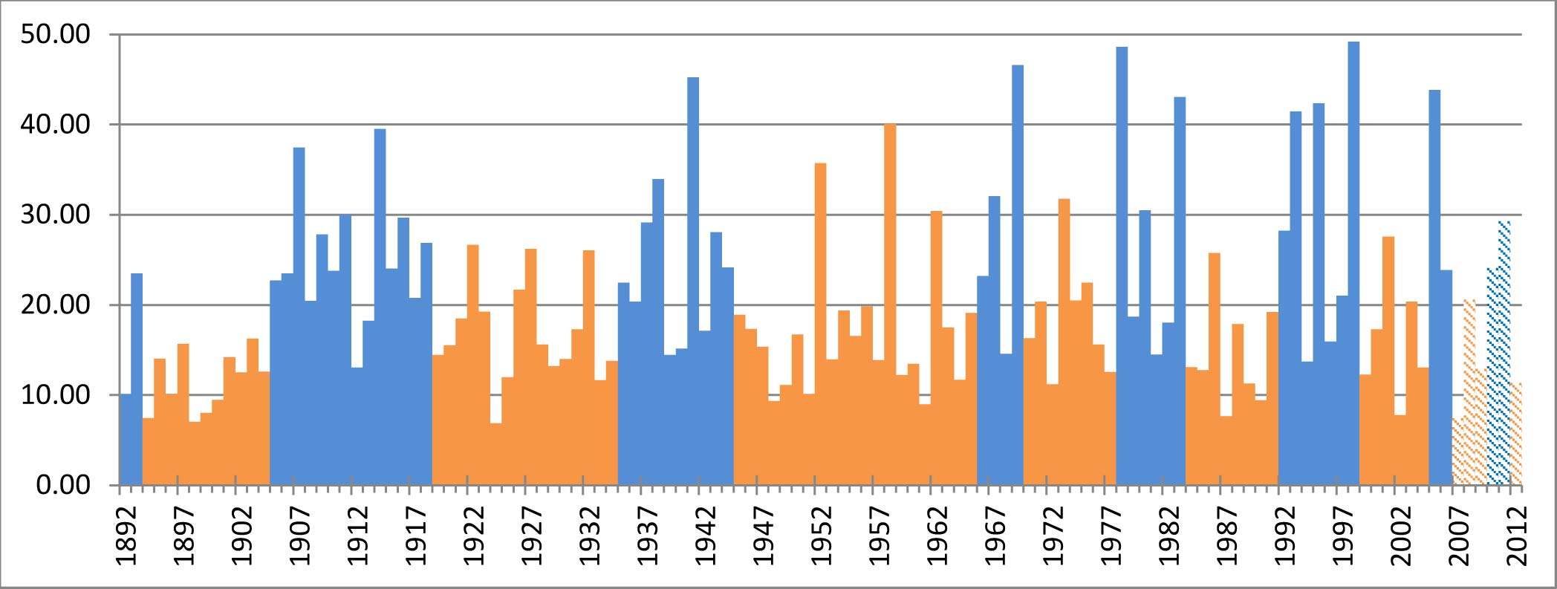

Wet (blue) and Dry (orange) Periods in the Ventura River Watershed

Source: Ventura River Watershed Management Plan (draft 2014)

**Rainfall**

Rainfall is highly variable in the watershed—seasonally, and from year to year. Rainfall typically occurs in just a few significant storms each year, which can come any time between October 15 and April 1, with 90% of the rainfall occurring between November and April. Snowfall is generally minimal and short-lived.

The Ventura River watershed’s rainfall patterns vary geographically. The rainfall totals from the watershed’s three climate zones shown in the table below illustrate that, on average, the watershed’s upper areas receive over twice as much rainfall, almost 20 inches more, as its lower areas.

[Precipitation Map](http://venturawatershed.org/wp-content/uploads/2013/05/Precipitation_Pg_Final.pdf)

|  |  |  |  |  |  |  |
| --- | --- | --- | --- | --- | --- | --- |
| Table 2.2.1.3 – Rainfall Average and Median (inches/year) | | | | | | |
|  | Station # | Water Years | Average | Median | Min | Max |
| Matilija Canyon | 207 | 1960-2012 | 35.17 | 28.74 | 28.74 | 89.05 |
| Downtown Ojai | 30 | 1906-2012 | 21.31 | 19.20 | 6.88 | 49.20 |
| Downtown Ventura | 66 | 1873-2012 | 15.46 | 14.12 | 4.62 | 38.65 |

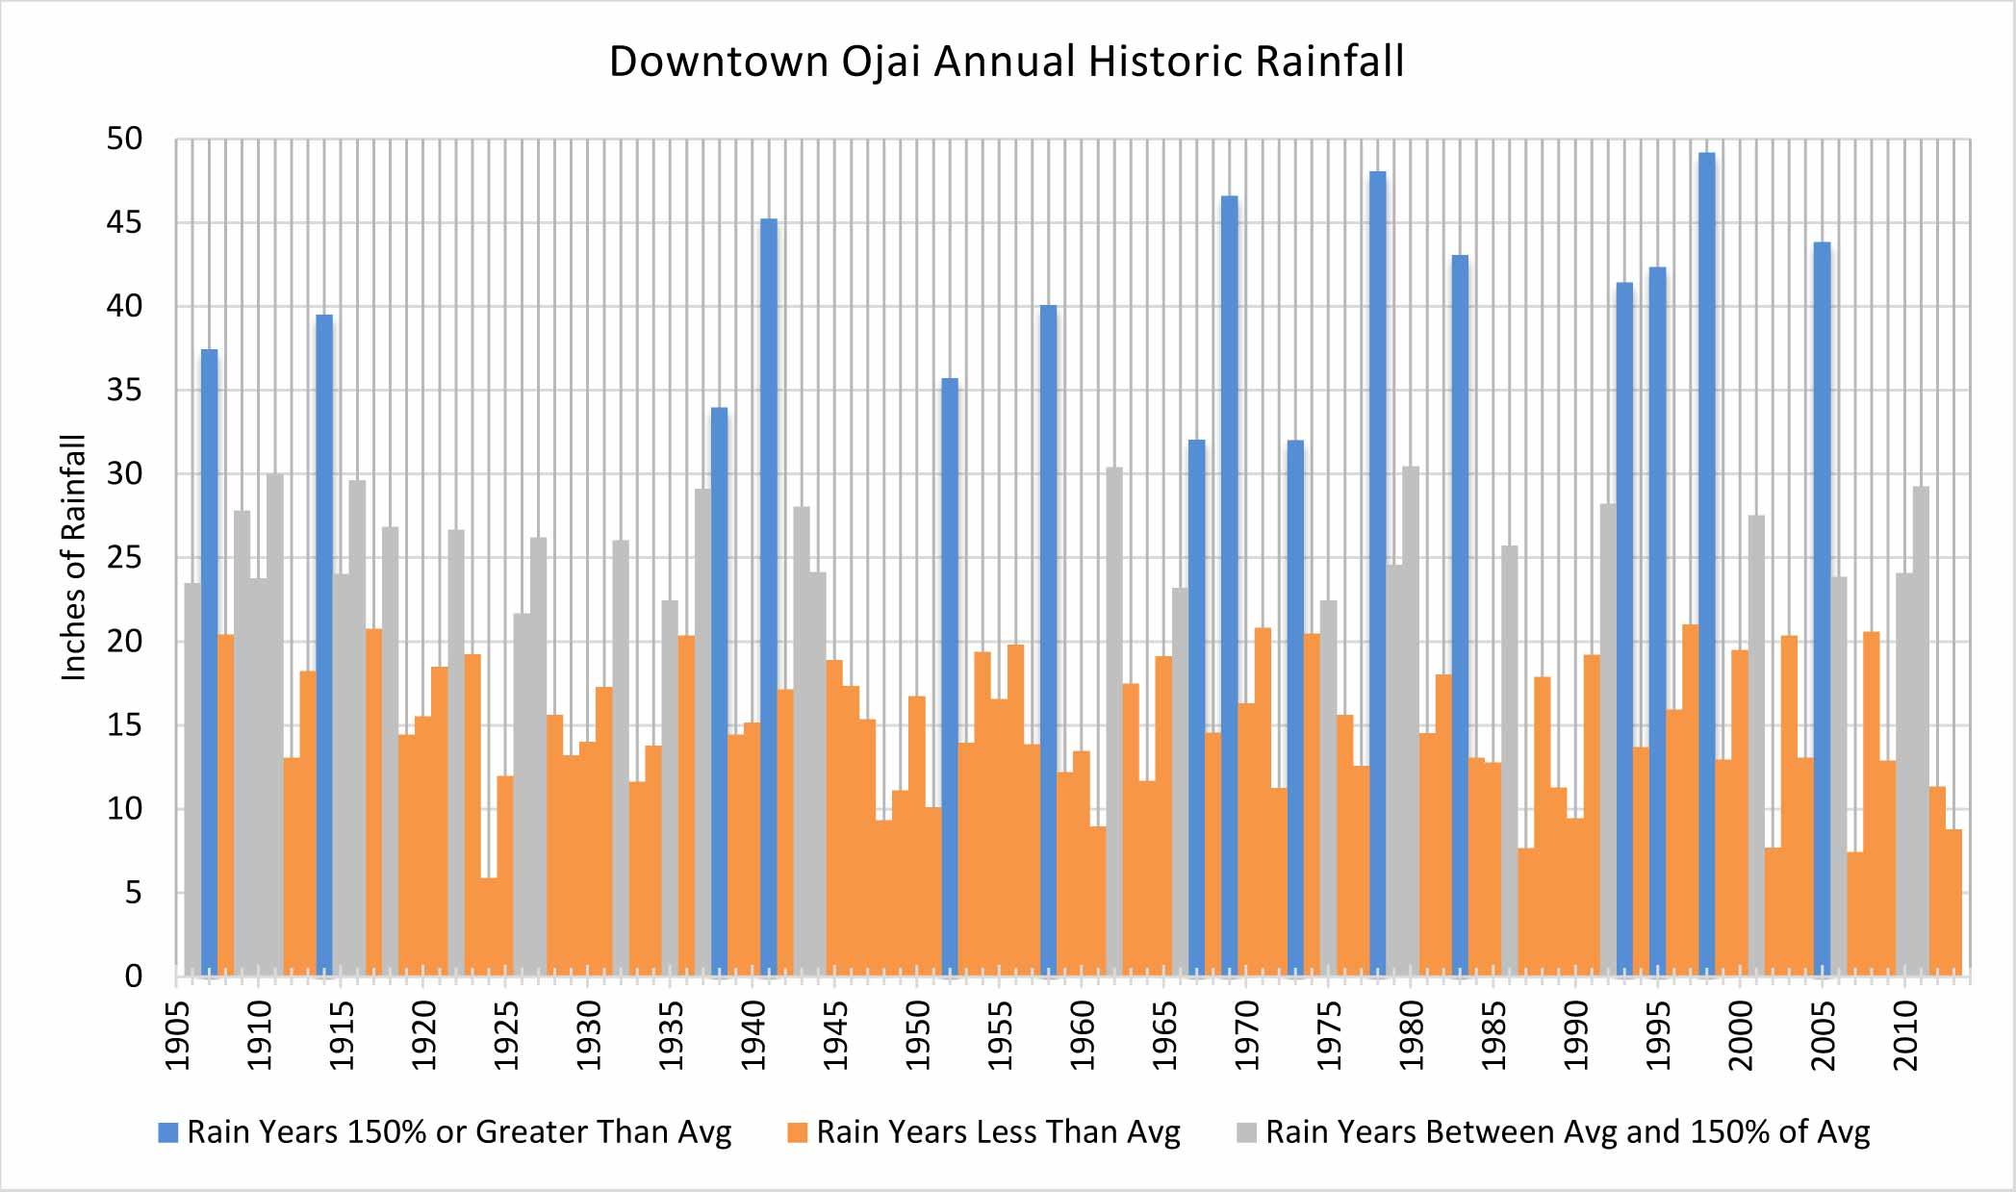

**Ojai’s Historical Rainfall**

Since 1906, annual rainfall in downtown Ojai has ranged from a low of 6.88 inches in 1924 to a high of 49.20 inches in 1998—a sevenfold variation. Average rainfall over this period was 21.33 inches. Since 1906, 67% of the years have had less than average rainfall in downtown Ojai. In this period, there have been 15 years of significantly high rainfall in downtown Ojai. (Significantly high rainfall years being those defined as having rainfall at least 150% above the average—or greater than 32 inches.)

As variable as its rainfall may be, the Ventura River watershed does have the distinction of receiving more rainfall than other watersheds in Ventura County. In 2005, 97 inches of rainfall was recorded on the Murrieta divide above Matilija Creek. The peak historic rainfall intensity was approximately 4.04 inches per hour measured during a 15-minute period at the Wheeler Gorge gauge in the mountains adjacent to Ojai.

**[Page 5]**

**Water District Info and Map**

The watershed’s 5 major urban water suppliers are described below. In addition, 11 smaller mutual water companies and 8 private water companies serve water in the watershed.

[Major Urban Water District Map](http://venturawatershed.org/wp-content/uploads/2013/05/MajorUrbanWaterSuppliers21.pdf)

To report a minor leak, call the appropriate water district below. To report a major leak, call 911.

**Casitas Municipal Water District**, 805/649-2251  
[www.casitaswater.org](http://www.casitaswater.org) On Facebook: www.facebook.com/fbsitecasitasmunicipalwaterdistrict

Casitas Municipal Water District (CMWD) is the primary water supplier in the watershed, providing water to both water resale agencies and retail customers. The City of Ventura is Casitas’ largest customer, and Lake Casitas water serves as one of the main sources of water for the city of Ventura. One of CMWD’s important functions is to serve as the “backup” water supply for a number of their customers, including 9 water suppliers as well as farmers, when groundwater supplies become depleted.

CMWD’s service area encompasses 150 square miles and includes the city of Ojai, Upper Ojai, the Ventura River Valley area, the city of Ventura south to about Mills Road, and the Rincon and beach area to the ocean and Santa Barbara County line.

CMWD gets its water from Lake Casitas, which is fed by both the surrounding drainages and water diverted from the Ventura River. The district also operates 1 well in the Mira Monte area.

**Ventura Water (City of Ventura)**, 805/667-6500 (805/650-8010 – emergency after hours)  
[www.cityofventura.net/water](http://www.cityofventura.net/water) On Facebook: www.facebook.com/venturawater

Ventura Water is the name of the City of Ventura’s department that supplies water, treats wastewater and manages stormwater. Ventura Water’s service area comprises several watersheds, including the lower part of the Ventura River watershed east of the Ventura River (primarily the Westside).

Lake Casitas is one of Ventura Water’s primary supply sources. The water received from CMWD may only be used within CMWD’s service area, which extends to about Mills Road. Ventura Water operates 4 groundwater wells at Foster Park (one of which is not currently operational because of damages sustained in the 2005 flood), and both a surface and subsurface intake on the Ventura River at Foster Park (though the surface diversion has not been operational since the mid-1990s). Ventura Water also depends upon groundwater from sources in the Santa Clara River watershed.

**Golden State Water Company**, **800/999-4033**[www.gswater.com/ojai](http://www.gswater.com/ojai)

Golden State Water Company is the only private water company in the watershed. They operate 5 wells and get water from CMWD.

Golden State’s service area includes the city of Ojai proper and some fringe county areas outside the city.

**Ventura River County Water District**, 805/646-3403  
 [www.vrcwd.com](http://www.vrcwd.com)

Ventura River County Water District is a small water district that provides water in the neighborhoods from Casitas Springs to the city of Ojai at the Vons shopping center. VRCWD obtains water from four wells located adjacent to the Ventura River. Water from CMWD is purchased on a continuing basis for some connections, and the district also has an agreement to purchase water from Casitas during emergencies and drought conditions.

**Meiners Oaks Water District**, 805/646-2114  
 [www.meinersoakswater.com](http://www.meinersoakswater.com)

Meiners Oaks Water District is a small water district that serves water to the Meiners Oaks community on the east side of the Ventura River. They operate 5 wells, and can use CMWD water as backup.

**[Page 7]**

**The Big 3**

**1. Reduce Landscape & Farm Water Use**

Irrigation is where we can REALLY make a difference. On average in California, over half of residential water is used outdoors. In the Ventura River watershed, that number is likely much higher given the number of large estates here. The watershed is also home to golf courses, large parks, and many public and private schools with extensive landscaped grounds. And over 5,000 acres of agricultural crops are irrigated with water from the watershed.

Reducing water used through irrigation can be done in many ways, from replacing thirsty plants (like turf) with low or no water using options (like natives), to ensuring that irrigation systems are running as efficiently as possible. Some options for reducing irrigation water use are fairly easy and inexpensive, like watering only in early morning hours, and others are more of an investment, like upgrading sprinkler heads to more efficient models.

There are people and resources available to help, both with expertise and in some cases incentives. Free, on-site irrigation efficiency surveys are available to ALL water users in Casitas Municipal Water District’s wholesale service area (most of the watershed). Below are links to a variety of helpful resources and information.

**Water Efficient Landscapes**

Free Onsite Irrigation Surveys [links to Page 2 “Free Onsite Water Use Surveys and Leak Detection”]

[Ocean Friendly Gardens – City of Ventura](http://www.cityofventura.net/water/ofg)

[Ocean Friendly Gardens – Video](https://www.youtube.com/watch?v=Qn3D32lUQ6g&list=PL-8051-cgin1zDsb6Mkqt_ikQJ6iYqgJi)

[Water Wise Gardening in Ventura County website](http://www.ventura.watersavingplants.com/)

[Low Water Using Landscape Ideas](http://www.saveourh2o.org/real-stories)

[Sprinklers](http://www.saveourh2o.org/sprinklers101) 101

[Master Gardeners](http://ucanr.edu/sites/VCMG/)

[Free Mulch from City of Ventura’s Cornucopia Gardens](http://www.cityofventura.net/pw/es/resrecycling)

**Agricultural Water Use**

Free Onsite Agricultural Irrigation Evaluations [links to Page 2, “Agricultural Irrigation Evaluations”]

[Evapotranspiration Data in Ojai](http://data.weatherreach.com/StationDetail?StationID=68&TableTimeInt=60)

[Subtropical Orchards Management Under Drought (Ben Faber, Farm Advisor](https://www.youtube.com/watch?v=hozgWiPbjI8&list=PLLjlfxpbNglYQxsSCr0TFtk2hUr_p1LDv&index=14&noredirect=1))

[Drought Tips for Growers](http://wwwcimis.water.ca.gov/cimis/resourceTechRefsDrought.jsp) (CIMIS)

[Water and Drought Online Seminar Series](http://ciwr.ucanr.edu/California_Drought_Expertise/Insights__Water_and_Drought_Online_Seminar_Series/) (Univ. of Calif.)

[Evapotranspiration Scheduling](http://ucmanagedrought.ucdavis.edu/Agriculture/Irrigation_Scheduling/Evapotranspiration_Scheduling_ET/) (Univ. of Calif.)

[Soil Moisture Monitoring](http://ucmanagedrought.ucdavis.edu/Agriculture/Irrigation_Scheduling/Soil_Moisture_Monitoring/) (Univ. of Calif.)

**Rebates on Water Saving Irrigation Equipment** [link to Page 3 “Free Water Saving Equip and Rebates]

Rebates are available on smart irrigation controllers, rain barrels, efficient sprinkler nozzles, and agricultural irrigation efficiency equipment. Restrictions apply.

**2. Improve Wasteful Plumping & Pipes**

Finding and repairing leaks—it’s one of those critical maintenance tasks that can not only save HUGE amounts of water, but also lots of money on your water bill. A tiny leak in a swimming pool’s plumbing system can lose 970 gallons of water in one day! A leaky faucet that drips at the rate of one drip per second can waste more than 3,000 gallons per year⎯that's about the amount of water needed to take 180 showers!

According to the US EPA, 10% of homes have leaks that waste 90 gallons or more per day. Common types of leaks, like worn toilet flappers, dripping faucets and other leaking valves are easily correctable. And help detecting leaks is available for free from Casitas Municipal Water District.

The Ventura River watershed has hard water, which makes regular maintenance of pipes and plumbing all the more important. Hard water has a high mineral content and these minerals form deposits, or scale, that stick to the interior of pipes and other water fixture surfaces. This can lead to clogs and other problems with pipes and appliances. Toilet flappers should be checked regularly for this reason, as these deposits can prevent a good seal—a common cause of continuous leaks.

Large amounts of water (and money) can also be saved by upgrading to newer, high-efficiency fixtures. Toilets are the biggest component of indoor water use, accounting for about 33% of indoor residential water use. Older toilets can use 3.5 or sometimes up to 5 gallons per flush. Newer models are using as little as 1.29 gallons per flush. Rebates on high efficiency toilets and washing machines are available.

**Free Water Saving Equipment & Rebates** [link to internal Page 3 “Free Water Saving Equipment and Rebates]

**Leaks**

**Identify a Leak**

If you need help determining if a leak may exist, call Casitas Municipal Water District at 805/649-2251 x128 for assistance.

**Report a Leak**

For a minor leak, call the appropriate water district’s phone number (Water District Contact Info) [link to Page 5 “Water District Contact Info”]. For a major leak, call 911 and the fire department will contact the appropriate water agency.

[How to Read your Meter and Detect Leaks (Ventura River County Water District)](http://www.vrcwd.com/how-to-read-your-water-meter-and-detect-leaks/)

[How to Locate your Meter and Detect Leaks – video (City of Ventura)](https://www.youtube.com/watch?v=gBUGCBLPERc&list=TLjUEZvkkht-upCu0Oq6xRcTLG9pUkroHW) [link to this video on our video page]

[How to Check for Leaks Inside and Outside the Home – video (City of Ventura)](https://www.youtube.com/watch?v=iX37I6ojoq4) [link to this video on our video page]

[How to Check your Irrigation System for Leaks – video (City of Ventura)](https://www.youtube.com/watch?v=M9kr9H42hk8) [add this to our video page, and link to]

[Is my Toilet Leaking?](http://www.saveourh2o.org/blog-posts/fix-leak-week)

[Drip Calculator](http://www.awwa.org/resources-tools/public-affairs/public-information/dripcalculator.aspx)

[How to Check your Swimming Pool for Leaks - video](https://www.youtube.com/watch?v=SwGb8BFqF70)

**3. Harvest & Reuse More Water**

Graywater is water from washing machines, bathroom sinks, showers, and bathtubs. This is fairly clean water that could be available for irrigation, but instead is typically mixed with “black” water (from the toilet) and sent down the sewer. The volume of graywater available for reuse is very significant. Because of this, in 2009 the state of California modified building code requirements to make it easier for people to install simple plumbing systems at their homes that make graywater available for irrigation. “Laundry to landscape” graywater systems that adhere to basic guidelines are now allowed without a building permit. Graywater offers such an easy and important way to supplement local water resources that you can commonly find workshops available locally offering instruction. Keep an eye on our listing of upcoming Classes & Events. [link to]

**Graywater**

[Graywater Code Guidelines](http://www.ventura.org/rma/build_safe/pdf/handouts/GW1_graywater_11x17.pdf) (no permit required)

Laundry to Landscape Graywater Video Excerpt (Art Ludwig) [link to this video on our video page]

[Graywater FAQ (Greywater Action)](http://greywateraction.org/faqs/greywater-recycling)

**Rainwater Harvesting**

When if finally does rain, wouldn’t it be nice to grab more of that water while we can? Harvesting rainwater can be done with rain barrels or cisterns that collect rooftop runoff, through “rain gardens” designed to capture and hold more water in the landscape, through engineered stormwater capture and treatment systems like bioswales, through “curb cuts” used to channel runoff from streets into planters, and many other techniques.

[Rainwater Harvesting – How much can I harvest?](http://www.surfrider.org/coastal-blog/entry/5191)

How to Use Rain Barrels – video (City of Ventura) [link to this video on our video page]

**[not a separate page]**

**Classes & Events**

June 3, 2014

**Public hearing on Meiners Oaks Water District’s draft Drought Contingency Plan**

More info: <http://meinersoakswater.com/> or 805/646-2114

June 14, 2014

**Free “SoCal Bloomers” class in Ventura.** - Discover colorful, climate appropriate plants to incorporate beautifully into your Water Wise landscape.

Hosted by **City of Ventura**

More info: www.cityofventura.net/water/landscape

June 16, 2014

**Ventura City Council review of draft Water Shortage Contingency Plan**

[need info]